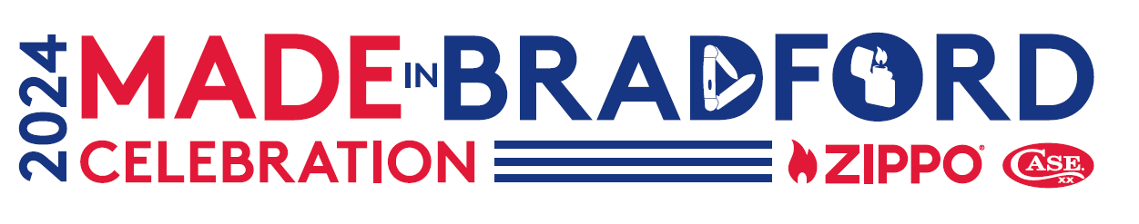
Made in Bradford Celebration – Swap Table Application
We invite Zippo and Case Collectors alike to apply to reserve a table in the swapping tent at the Made in Bradford Celebration, hosted by the Zippo/Case Museum on Saturday, July 20th from 10 a.m. to 4 p.m.
There is no cost to reserve a swap table. Each collector is eligible for an 8ft table and 2 chairs. Submitting this application does not guarantee you a spot under the swapping tent. You will be contacted by an event representative if you are awarded a swap table prior to the event.
Zippo and Case Collectors interested in exhibiting at the Made in Bradford Celebration should complete this form and submit it to events@caseknives.com by Monday, June 3, 2024. Spaces are limited, we recommend returning this form as soon as possible. Spaces will be awarded on a first come first serve basis based on date application is received. Collectors will be notified of acceptance or denial by Thursday, June 20, 2024.
Name: ________________________________________________

Case Collectors Club® Membership Number (if applicable): _________________________

Contact Phone: _______________________________________

E-mail: _________________________________________________

Questions / Special Requirements:
____________________________________________________________________________________
Sales Tax Reporting: If you are selling Case® knives, Zippo® lighters, or other tangible property at the event, Pennsylvania Law requires that you collect and remit 6.0% sales tax on the amount of sale.
Parameters: Please note that any form of food, illegal substance or competitive goods will not be permitted for sale in this tent. Exhibitors are only permitted to sell genuine Case® brand knives/accessories and/or Zippo® brand lighters/accessories. No electricity or communication lines will be provided, and generators will not be permitted. Setup will be 8:00-9:30 a.m. and teardown will be 4:00-6:00 p.m. on Saturday, July 20, 2024. We ask that all swappers abide by this schedule. There will be staff on hand to assist with loading in and loading out, as needed.
*Zippo and Case welcome guests with disabilities. Our staff if committed to providing the highest quality visit for each and every exhibitor to the extent that we can reasonably accommodate*

